Chapter 10 - Circles Excercise Ex. 10.1
Solution 1
(i) The centre of a circle lies in interior of the circle. (exterior/interior)
(ii) A point, whose distance from the centre of a circle is greater than its radius lies in exterior of
the circle. (exterior/interior)
(iii) The longest chord of a circle is a diameter of the circle.
(iv) An arc is a semicircle when its ends are the ends of a diameter.
(v) Segment of a circle is the region between an arc and chord of the circle.
(vi) A circle divides the plane, on which it lies, in three parts.
Solution 2
(i) True, all the points on circle are at equal distance from the centre of circle, and this equal distance
it called as radius of circle.
(ii) False, on a circle there are infinite points. So, we can draw infinite number of chords of given length. Hence, a circle has infinite number of equal chords.
(iii) False, consider three arcs of same length as AB, BC and CA. Now we may observe that for minor arc BDC. CAB is major arc. So AB, BC and CA are minor arcs of circle.
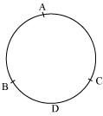

(iv) True, let AB be a chord which is twice as long as its radius. In this situation our chord will be passing through centre of circle. So it will be the diameter of circle.

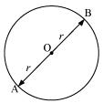

(v) False, sector is the region between an arc and two radii joining the centre to the end points of the arc as in the given figure OAB is the sector of circle.

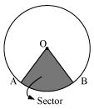

(vi) True, A circle is a two dimensional figure and it can also be referred as plane figure.

Chapter 10 - Circles Excercise Ex. 10.2
Solution 1
A circle is a collection of points which are equidistant from a fix point. This fix point is called as the centre of circle and this equal distance is called as radius of circle. And thus shape of a circle depends on the radius of the circle.
So, if we try to superimpose two circles of equal radius, one each other both circles will cover each other.
So, two circles are congruent if they have equal radius.

Now consider two congruent circles having centre O and O' and two chords AB and CD of equal lengths

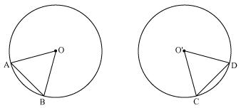

Now in AOB and CO'D
AB = CD (chords of same length)
OA = O'C (radii of congruent circles)
OB = O'D (radii of congruent circles)
AOB CO'D (SSS congruence rule)
AOB = CO'D (by CPCT)
Hence equal chords of congruent circles subtend equal angles at their centres.
Solution 2
Let us consider two congruent circles (circles of same radius) with centres as O and O'.

In AOB and CO'D
AOB = CO'D (given)
OA = O'C (radii of congruent circles)
OB = O'D (radii of congruent circles)
AOB CO'D (SSS congruence rule)
AB = CD (by CPCT)
Hence, if chords of congruent circles subtend equal angles at their centres then chords are equal.

Chapter 10 - Circles Excercise Ex. 10.3
Solution 1
Consider the following pair of circles.
(i) circles don't intersect each other at any point, so circles are not having any point in common.
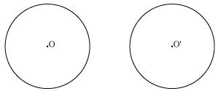

(ii) Circles touch each other only at one point P so there is only 1 point in common.
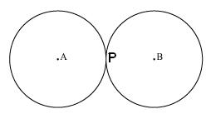

(iii) Circles touch each other at 1 point X only. So the circles have 1 point in common.
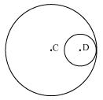
(iv) These circles intersect each other at two points P and Q. So the circles have two points in common. We may observe that there can be maximum 2 points in common.
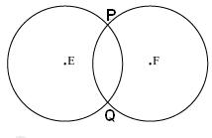
We can have a situation in which two congruent circles are superimposed on each other, this situation can be referred as if we are drawing circle two times.
Solution 2
Following are the steps of construction:
Step1. Take the given circle centered at point O.
Step2. Take any two different chords AB and CD of this circle and draw perpendicular bisectors of these
chords.
Step3. Let these perpendicular bisectors meet at point O. Now, O is the centre of given circle.

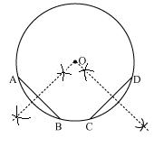
Solution 3
Consider two circles centered at point O and O' intersect each other at point A and B respectively.
Join AB. AB is the chord for circle centered at O, so perpendicular bisector of AB will pass through O.
Again AB is also chord of circle centered at O', so, perpendicular bisector of AB will also pass through O'.
Clearly centres of these circles lie on the perpendicular bisector of common chord.

Chapter 10 - Circles Excercise Ex. 10.4
Solution 1

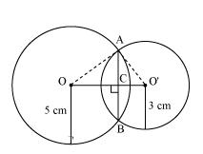

Let radius of circle centered at O and O' be 5 cm and 3 cm respectively.
OA = OB = 5 cm
O'A = O'B = 3 cm
OO' will be the perpendicular bisector of chord AB.
AC = CB
Given that OO' = 4 cm
Let OC be x. so, O'C will be 4 - x
In OAC
OA² = AC² + OC²
5² = AC² + x²
25 - x² = AC² ... (1)
In O'AC
O'A² = AC² + O'C²
3² = AC² + (4 - x)²
9 = AC² + 16 + x² - 8x
AC² = - x² - 7 + 8x ... (2)
From equations (1) and (2), we have
25 - x² = - x² - 7 + 8x
8x = 32
x = 4
So, the common chord will pass through the centre of smaller circle i.e. O'. and hence it will be diameter of smaller circle.

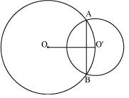

Now, AC² = 25 - x² = 25 - 4² = 25 - 16 = 9
AC = 3 m
The length of the common chord AB = 2 AC = (2 3) m = 6 m
Solution 2
Let PQ and RS are two equal chords of a given circle and there are intersecting each other at point T.

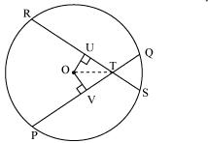

Draw perpendiculars OV and OU on these chords.
In OVT and OUT
OV = OU (Equal chords of a circle are equidistant from the centre)
OVT = OUT (Each 90º)
OT = OT (common)
OVT OUT (RHS congruence rule)
VT = UT (by CPCT) ... (1)
It is given that
PQ = RS ... ... ... ... (2)
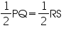
PV = RU ... ... ... ... (3)
On adding equations (1) and (3), we have
PV + VT = RU + UT
PT = RT ... ... ... ... (4)
On subtracting equation (4) from equation (2), we have
PQ - PT = RS - RT
QT = ST ... ... ... ... (5)
Equations (4) and (5) shows that the corresponding segments of
chords PQ and RS are congruent to each other.
Solution 3
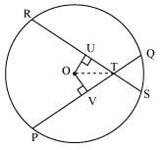

Let PQ and RS are two equal chords of a given circle and there are intersecting each other at point T.
Draw perpendiculars OV and OU on these chords.
In OVT and OUT
OV = OU (Equal chords of a circle are equidistant from the centre)
OVT = OUT (Each 90º)
OT = OT (common)
OVT OUT (RHS congruence rule)
OTV = OTU (by CPCT)
Hence, the line joining the point of intersection to the centre makes equal angles with the chords.
Solution 4
Let us draw a perpendicular OM on line AD.
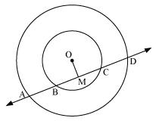
Here, BC is chord of smaller circle and AD is chord of bigger circle.
We know that the perpendicular drawn from centre of circle bisects the chord.
BM = MC ... (1)
And AM = MD ... (2)
Subtracting equations (2) from (1), we have
AM - BM = MD - MC
AB = CD
Solution 5

Draw perpendiculars OA and OB on RS and SM respectively.
Let R, S and M be the position of Reshma, Salma and Mandip respectively.

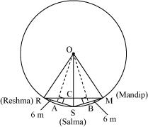

AR = AS = = 3cm
OR = OS = OM = 5 m (radii of circle)
In OAR
OA² + AR² = OR²
OA² + (3 m)² = (5 m)²
OA² = (25 - 9) m² = 16 m²
OA = 4 m
We know that in an isosceles triangle altitude divides the base, so in RSM
RCS will be of 90º and RC = CM
Area of ORS = OARS
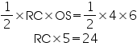
RC = 4.8
RM = 2RC = 2(4.8)= 9.6
So, distance between Reshma and Mandip is 9.6 m.
Solution 6
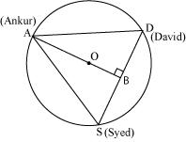

Given that AS = SD = DA
So, ASD is a equilateral triangle
OA (radius) = 20 m.
Medians of equilateral triangle pass through the circum centre (O) of the equilateral triangle ABC.
We also know that median intersect each other at the 2: 1. As AB is the median of equilateral triangle ABC, we can write
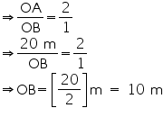

AB = OA + OB = (20 + 10) m = 30 m.
In ABD
AD² = AB² + BD²
AD² = (30)² + 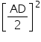
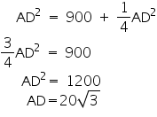
So, length of string of each phone will be 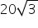 m.

Chapter 10 - Circles Excercise Ex. 10.5
Solution 1
We may observe that
AOC = AOB + BOC
= 60º + 30º
= 90º
We know that angle subtended by an arc at centre is double the angle subtended by it any point on the remaining part of the circle.

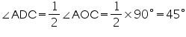
Solution 2
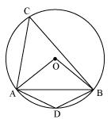

In OAB
AB = OA = OB = radius
OAB is an equilateral triangle.
So, each interior angle of this triangle will be of 60º

AOB = 60º

Now, 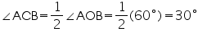

In cyclic quadrilateral ACBD
ACB + ADB = 180º (Opposite angle in cyclic quadrilateral)
ADB = 180º - 30º = 150º
So, angle subtended by this chord at a point on major arc and minor arc are 30º and 150º respectively.
Solution 3
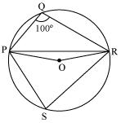

Consider PR as a chord of circle.
Take any point S on major arc of circle.
Now PQRS is a cyclic quadrilateral.
PQR + PSR = 180º (Opposite angles of cyclic quadrilateral)
PSR = 180º - 100º = 80º
We know that angle subtended by an arc at centre is double the angle subtended by it any point on the remaining part of the circle.
POR = 2PSR = 2 (80º) = 160º
In POR
OP = OR (radii of same circle)
OPR = ORP (Angles opposite equal sides of a triangle)
OPR + ORP + POR = 180º (Angle sum property of a triangle)
2 OPR + 160º= 180º
2 OPR = 180º - 160º = 20º
OPR = 10º
Solution 4
In ABC
BAC + ABC + ACB = 180º (Angle sum property of a triangle)
BAC + 69º + 31º = 180º
BAC = 180º - 100º
BAC = 80º
BDC = BAC = 80º (Angles in same segment of circle are equal)
Solution 5
In CDE
CDE + DCE = CEB (Exterior angle)
CDE + 20º = 130º
CDE = 110º
But BAC = CDE (Angles in same segment of circle)
BAC = 110º
Solution 6
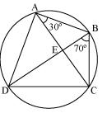
For chord CD
CBD = CAD (Angles in same segment)
CAD = 70º
BAD = BAC + CAD = 30º + 70º = 100º
BCD + BAD = 180º (Opposite angles of a cyclic quadrilateral)
BCD + 100º = 180º
BCD = 80º
In ABC
AB = BC (given)
BCA = CAB (Angles opposite to equal sides of a triangle)
BCA = 30º
We have BCD = 80º
BCA + ACD = 80º
30º + ACD = 80º
ACD = 50º
ECD = 50º
Solution 7
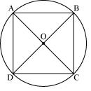

Let ABCD a cyclic quadrilateral having diagonals as BD and AC intersecting each other at point O.
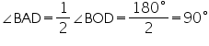 (Consider BD as a chord)

BCD + BAD = 180º (Cyclic quadrilateral)
BCD = 180º - 90º = 90º
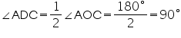 (Considering AC as a chord)

ADC + ABC = 180º (Cyclic quadrilateral)
90º + ABC = 180º
ABC = 90º
Here, each interior angle of cyclic quadrilateral is of 90º. Hence it is a rectangle.
Solution 8
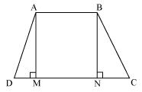

Consider a trapezium ABCD with AB | |CD and BC = AD Draw AM CD and BN CD
In AMD and BNC
AD = BC (Given)
AMD = BNC (By construction each is 90º)
AM = BM (Perpendicular distance between two parallel lines is same)
AMD BNC (RHS congruence rule)
ADC = BCD (CPCT) ... (1)
BAD and ADC are on same side of transversal AD
BAD + ADC = 180º ... (2)
BAD + BCD = 180º [Using equation (1)]
This equation shows that the opposite angles are supplementary.
So, ABCD is a cyclic quadrilateral.
Solution 9

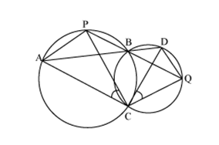

Join chords AP and DQ
For chord AP
PBA = ACP (Angles in same segment) ... (1)
For chord DQ
DBQ = QCD (Angles in same segment) ... (2)
ABD and PBQ are line segments intersecting at B.
PBA = DBQ (Vertically opposite angles) ... (3)
From equations (1), (2) and (3), we have
ACP = QCD
Solution 10
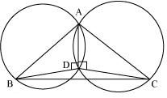

Consider a ABC
Two circles are drawn while taking AB and AC as diameter.
Let they intersect each other at D and let D does not lie on BC.
Join AD
ADB = 90º (Angle subtend by semicircle)
ADC = 90º (Angle subtend by semicircle)
BDC = ADB + ADC = 90º + 90º = 180º
Hence BDC is straight line and our assumption was wrong.
Thus, Point D lies on third side BC of ABC

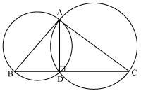
Solution 11
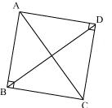

In ABC
ABC + BCA + CAB = 180º (Angle sum property of a triangle)
90º + BCA + CAB = 180º
BCA + CAB = 90º ... (1)
In ADC
CDA + ACD + DAC = 180º (Angle sum property of a triangle)
90º + ACD + DAC = 180º
ACD + DAC = 90º ... (2)
Adding equations (1) and (2), we have
BCA + CAB + ACD + DAC = 180º
(BCA + ACD) + (CAB + DAC) = 180º BCD + DAB = 180º ... (3)
But it is given that
B + D = 90º + 90º = 180º ... (4)
From equations (3) and (4), we can see that quadrilateral ABCD is having sum of measures of opposite angles as 180º.
So, it is a cyclic quadrilateral.
Consider chord CD.
Now, CAD = CBD (Angles in same segment)

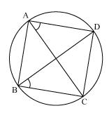
Solution 12
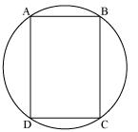

Let ABCD be a cyclic parallelogram.
A + C = 180º (Opposite angle of cyclic quadrilateral) ... (1)
We know that opposite angles of a parallelogram are equal
A = C and B = D
From equation (1)
A + C = 180º
A + A = 180º
2 A = 180º
A = 90º
Parallelogram ABCD is having its one of interior angles as 90º, so, it is a rectangle.
PROMOTED CONTENT

This Made Coimbatore Man's Income Soar To Rs. 11,600,000!
Storiespace

A Girl From Coimbatore Became a Billionaire Using This Method
Storiespace

A Girl From Coimbatore Became A Billionaire Using This Method
Storiespace

वह बहुत गरीब थी लेकिन अब करोडो कमाती है

Chapter 10 - Circles Excercise Ex. 10.6
Solution 1
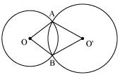

Let two circles having their centres as O and intersect each other at point A and B respectively.
Construction: Let us join OO',

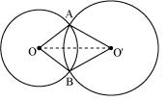

Now in AOO' and BOO'
OA = OB (radius of circle 1)
O'A = O'B (radius of circle 2)
OO' = OO' (common)
AOO' BOO' (by SSS congruence rule)
OAO' = OBO' (by CPCT)
So, line of centres of two intersecting circles subtends equal angles at the two points of intersection.
Solution 2
Draw OM AB and ON CD. Join OB and OD

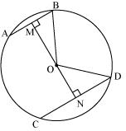
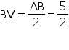 (Perpendicular from centre bisects the chord)
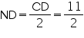
Let ON be x, so OM will be 6 - x
In MOB
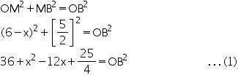
In NOD
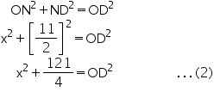

We have OB = OD (radii of same circle)
So, from equation (1) and (2)

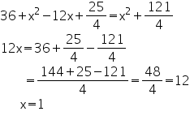
From equation (2)

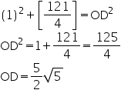
So, radius of circle is found to be 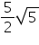 cm.
Solution 3
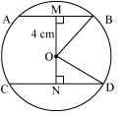

Distance of smaller chord AB from centre of circle = 4 cm.
OM = 4 cm
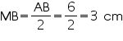
In OMB
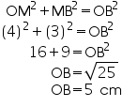
In OND
OD=OB=5cm (radii of same circle)
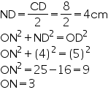

So, distance of bigger chord from centre is 3 cm.
Solution 4
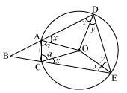
In AOD and COE
OA = OC (radii of same circle)
OD = OE (radii of same circle)
AD = CE (given)
AOD COE (SSS congruence rule)
OAD = OCE (by CPCT) ... (1)
ODA = OEC (by CPCT) ... (2)
We also have
OAD = ODA (As OA = OD) ... (3)
From equations (1), (2) and (3), we have
OAD = OCE = ODA = OEC
Let OAD = OCE = ODA = OEC = x
In OAC,
OA = OC
OCA = OAC (let a)
In ODE,
OD = OE
OED = ODE (let y)
ADEC is a cyclic quadrilateral
CAD + DEC = 180º (opposite angles are supplementary)
x + a + x + y = 180º
2x + a + y = 180º
y = 180 - 2x - a ... (4)
But DOE = 180 - 2y
And AOC = 180 - 2a
Now, DOE - AOC = 2a - 2y = 2a - 2 (180 - 2x - a)
= 4a + 4x - 360º ... (5)
Now, BAC + CAD = 180 (Linear pair)
BAC = 180 - CAD = 180 - (a + x)
Similarly, ACB = 180 - (a + x)
Now, in ABC
ABC + BAC + ACB = 180 (Angle sum property of a triangle)
ABC = 180 - BAC - ACB
= 180 - (180 - a - x) - (180 - a -x)
= 2a + 2x - 180
= [4a + 4x - 360º]
ABC = [DOE - AOC] [Using equation (5)]
Solution 5
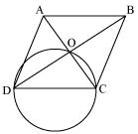
Let ABCD be a rhombus in which diagonals are intersecting at point O and a circle is drawn taking side CD as its diameter.
We know that angle in a semicircle is of 90º.
COD = 90º
Also in rhombus the diagonals intersect each other at 90º
AOB = BOC = COD = DOA = 90º
So, point O has to lie on the circle.
Solution 6
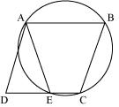

We see that ABCE is a cyclic quadrilateral and in a cyclic quadrilateral sum of opposite angles is 180º
AEC + CBA = 180º
AEC + AED = 180º (linear pair)
AED = CBA ... (1)
For a parallelogram opposite angles are equal.
ADE = CBA ... (2)
From (1) and (2)
AED = ADE
AD = AE (angles opposite to equal sides of a triangle)
Solution 7
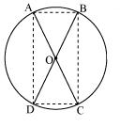
Let two chords AB and CD are intersecting each other at point O.
In AOB and COD
OA = OC (given)
OB = OD (given)
AOB = COD (vertically opposite angles)
AOB COD (SAS congruence rule)
AB = CD (by CPCT)
Similarly, we can prove AOD COB
AD = CB (by CPCT)

Since in quadrilateral ACBD opposite sides are equal in length.
Hence, ACBD is a parallelogram.
We know that opposite angles of a parallelogram are equal
A = C
But A + C = 180º (ABCD is a cyclic quadrilateral)
A + A = 180º
A = 180º
A = 90º
As ACBD is a parallelogram and one of its interior angles is 90º, so it is a rectangle.
A is the angle subtended by chord BD. And as A = 90º, so BD should be diameter of circle. Similarly AC is diameter of circle.

Solution 8
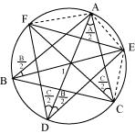

It is given that BE is the bisector of B
ABE =
But ADE = ABE (angles in same segment for chord AE)
ADE =
Similarly, ACF = ADF = 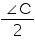 (angle in same segment for chord AF)
Now, D = ADE + ADF
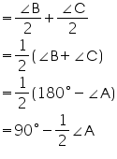
Similarly we can prove that
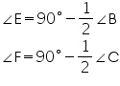

Solution 9
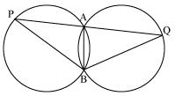

AB is common chord in both congruent circles.
APB = AQB
Now in BPQ
APB = AQB
BP = BQ (angles opposite to equal sides of a triangle)
Solution 10
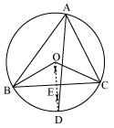

Let perpendicular bisector of side BC and angle bisector of A meet at point D.
Let perpendicular bisector of side BC intersects it at E.
Perpendicular bisector of side BC will pass through circum centre O of circle. Now, BOC and BAC are the angles subtended by arc BC at the centre and a point A on the remaining part of the circle respectively.
We also know that the angle subtended by an arc at the centre is double the angle subtended by it at any point on the remaining part of the circle.
BOC = 2 BAC = 2A ... (1)
In BOE and COE
OE = OE (common)
OB = OC (radii of same circle)
OEB = OEC (Each 90º as OD BC)
BOE COE (RHS congruence rule)
BOE = COE (by CPCT) ... (2)
But BOE + COE = BOC
BOE +BOE = 2 A [Using equations (1) and (2)]
BOE = 2A
BOE = A
BOE = COE = A
The perpendicular bisector of side BC and angle bisector of A meet at point D.
BOD = BOE = A ... (3)
Since AD is the bisector of angle A
BAD = 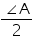
2BAD = A ... (4)
From equations (3) and (4), we have
BOD = 2 BAD
It is possible only if BD will be a chord of the circle. For this the point D lies on circum circle.
Therefore, the perpendicular bisector of side BC and angle bisector of A meet on the circum circle of triangle ABC.

